RMT TfL No.1 Branch Meetings for 2016
For London Underground Managers, Admin
& Technical services plus all TfL
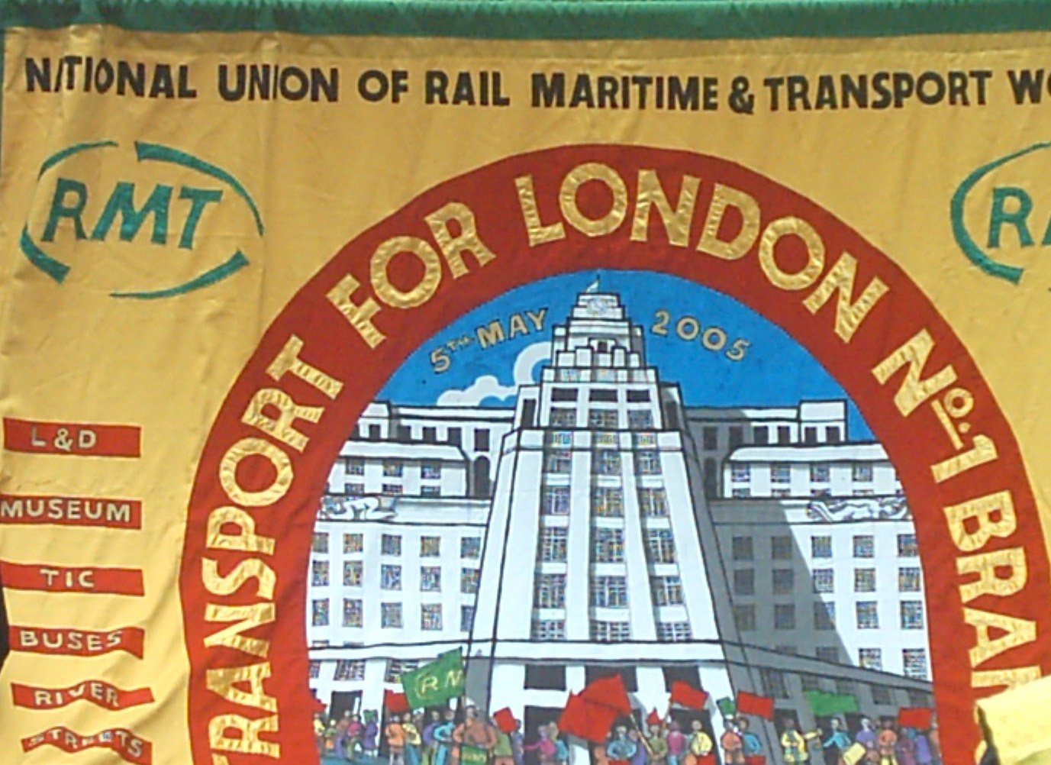
Change of venue
Our branch meetings are held upstairs, 17.00-19.00. Every TFL payday in the Blue Eyed Maid public house.
5 mins walk left out of the Borough High Street exit of London Bridge tube.

17th Aug, 14th Sept, 12th Oct, 9th Nov, 7th Dec AGM
Find out what is happening in your work area and across London. Have your say and experience RMT’s ‘Unity is strength.

Paul Rutland: Branch Secretary on 0794 187 7966
p.rutland@virgin.net
Contact Linda Wiles: Branch Chair on 0799 089 4576 linda.j.wiles@ntlworld.com
Helpline 0800 376 3706 or www.rmt.org.uk

