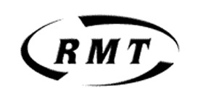

Latest proposals- The facts

TSSA has sent out a misleading bulletin which says that all supervisors will get CSM jobs.

Here is RMT's breakdown of what is actually on offer and how it will affect each grade.
- SS1/SS2 - Guaranteed a CSM position but location and CSM grading (1 or 2) decided by LU on assessment.

- SSMF/SS3 - Guaranteed CSS post but while most SSMF/SS3s work in outer zones the CSS jobs will be mainly in Zone 1.

- SAMF/SCRA - Can apply for CSS2 jobs on same salary as present SAMF. These jobs will be in the outer zones on local stations whereas most SAMFs and SCRAs work in Z1 at present.

- CSAs - The CSS2 grade means CSAs will not run local stations but will have to take on nights where night running is introduced.

- CSA2 - LU is still committed to introduce this £23K starter grade.

In addition to any immediate impact the lowering of salaries for each function will hit promotional prospects in general
The strikes are still on
What LUL are offering is not enough to settle – stand firm- stand together

