Congress House, Great Russell Street, London WC1B 3LS
telephone: 020 7636 4030 fax: 020 7636 0632 www.tuc.org.uk

General Secretary: Brendan Barber Deputy General Secretary: Frances O’Grady
Assistant General Secretary: Kay Carberry

To: All Union Delegates and Observers to the  2013 TUC Young Members’ Conference | our ref YMC 2013  date: 4 March 2013  contact: Carl Roper  direct line: 020 7467 1250  email: croper@tuc.org.uk
Dear Colleague

2013 TUC Young Members’ Conference
Thank you for registering to attend the 2013 TUC Young Members’ Conference.

The Conference will be held at the TUC, Congress House, Great Russell Street, London WC1B 3LS.

For your information the times of the Conference sessions are as follows:

AM PM

Saturday 23rd March 12noon (registration) 1.30 – 6.30pm
Sunday 24th March 10.00am to finish no later than 4.00pm

Enclosed are the following:

- Conference agenda which includes start times for the Conference sessions;
- Map and directions to Congress House;
- Invitation to the Conference Saturday Social
- Guide to conference procedures;
- Seating chart

Accommodation
For those delegates and observers who have registered for accommodation your reservation has been made at the St Giles Hotel (http://centrallondon.stgiles.com) – your booking reference and details are attached to this letter. In the event that you thought you had registered for accommodation and no details are attached, please contact Karina Ross on kross@tuc.org.uk or 020 7467 1250 as a matter of urgency.
Registration
On arrival at Congress House please could you make your way to the registration desk. Registration will be open from 12noon on Saturday 23rd March with the opening session of Conference starting at 1.30pm. A sandwich lunch and refreshments will be provided on arrival.

Please could you make every effort to arrive early to help avoid a last minute rush.

Conference packs (to include: credential, voting cards, workshop allocation forms and monitoring forms) will be available for collection upon registration.

Please note that no substitute credentials will be issued on the day. Conference packs and credentials will only be issued to delegates and observers who have been pre-registered by their unions. If unions wish to substitute delegates, the TUC must be notified no later than two days before the start of Conference. No substitute credentials will be issued on the day.

Saturday Social
All delegates and observers to the Conference are invited to attend a Saturday Social from 7-10pm in the Marble Hall, Congress House. A hot buffet will be provided and a pay bar will be available. An invitation is enclosed with this letter – please bring this invitation with you as it will entitle you to two complimentary drinks.

Seating Chart
Also enclosed is a seating chart. Delegates are requested to sit in the places reserved for their particular union. Observers are asked to sit in the area reserved for them at the back of the conference room.

Twitter
If you use twitter and would like to ‘tweet’ about Conference, the hashtag will be #YMC2013.

Leafleting in Congress House
Leafleting, lobbying and selling of unauthorised literature is not permitted within any part of the Conference venue.

If you have any queries in relation to room bookings or credentials please contact Karina Ross on kross@tuc.org.uk or 020 7467 1250.

Yours sincerely
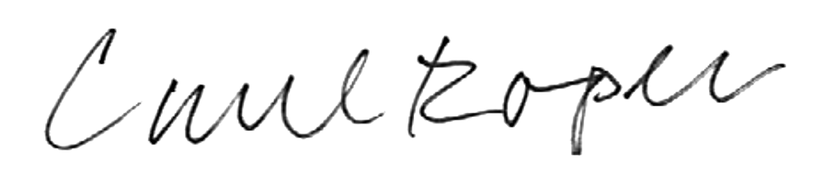

Carl Roper
TUC National Organiser

