URGENT NOTICE:
LETTERS FROM MANAGEMENT
RMT London Transport Regional Council Disabled Members Covid-19 Bulletin no.2
20 March 2020

A reminder:
TfL and London Underground Ltd have confirmed that if you are staying away from work in line with government health advice, the company supports you in doing that and you will not lose pay or suffer any detriment.

This includes staying away from work if:
- you have Covid-19 symptoms
- someone in your household has Covid-19 symptoms
- you are in an ‘at risk’ category, which includes many disabled workers and those with health conditions

Unfortunately, some employing managers have not been adhering to this, and have sent some staff totally unacceptable letters, including telling them to attend work.

RMT has told the company in no uncertain terms that this must stop. The company has confirmed that it has not authorised managers to send letters like this, and that they must not do so. It has apologised for the distress caused.

If you receive a letter telling you to attend work, or which concerns you in any way, contact your RMT rep immediately. Do not attend work if government guidance is for you to stay away from work.

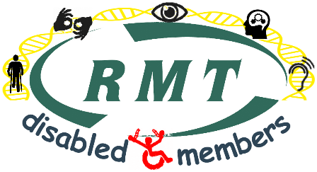
Keep up to date with government advice on the NHS website. www.nhs.uk/conditions/coronavirus-covid-19/

Janine Booth
Disability Officer
RMT London Transport Region
www.rmtlondoncalling.org.uk/disability

