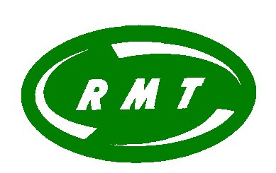

RMT Night Tube Members' Meeting.

Friday 18 May 9pm Brixton Union Room

Come meet reps, ask questions, put forward your issues.

RMT invites Night Tube staff to meet your union reps:

- know your rights
- raise your issues
- demand better conditions

Friday 18 May 21:00
Brixton Union Room
(meet at the station gateline for directions)

London Underground management have agreed to review Night Tube station staff’s working conditions. RMT is calling for:

- a 16-hour week (more pay and more access to in-work benefits)
- increased staffing
- protection from harassment and assault
- better access to admin support
- training, appointments, etc, available during our working hours
- better access to promotion and to transfer into full-time posts.

We want your input. Do you have other issues and concerns? What can you do to help us win these improvements? What is most important to you?

Come to this meeting! RMT reps will be there to discuss with you, listen to your views and answer your questions.

If you are not already an RMT member, you can join at this meeting.

Although this meeting is mainly aimed at Night Tube station staff, Night Tube drivers are welcome too.

Yours sincerely

John Leach
REGIONAL ORGANISER

