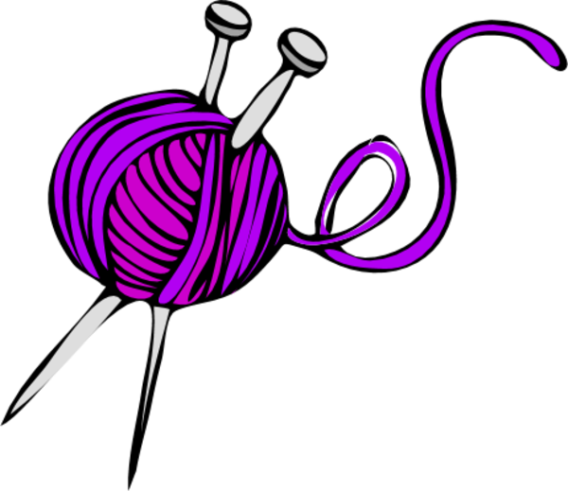
The Met Craft Club

Knitting, crochet basics, colouring therapy.

Find us in the meeting room at Harrow-on-the-Hill on
Wednesday 11th May 2016 12.00 to 15.30

Bring your knitting needles, crochet hooks and yarn if you can. All Welcome!!!

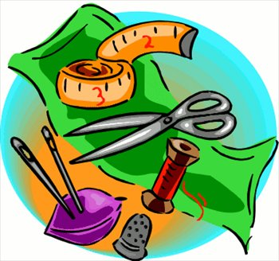
For more Info, visit our Facebook group: The Met Craft Club or email us: themetcraftclub@yahoo.co.uk

